Edge Detection

Digital Image Processing

Crehul Vlad & Hornai Vlad

<https://github.com/VladC12/Edge-Detection-PNI>

Contents

Input Image: 3

Prewitt 3

Prewitt Results: 4

Sobel 4

Sobel Results: 5

Compass: 6

Compass Results: 6

Nevatia Babu 7

Nevatia Babu Results: 7

Bibliography 7

# Edge Detection

Edge detection includes a variety of mathematical methods that aim at identifying points in a digital image at which the image brightness changes sharply or, more formally, has discontinuities. The points at which image brightness changes sharply are typically organized into a set of curved line segments termed edges. Edge detection is a fundamental tool in image processing, machine vision and computer vision, particularly in the areas of feature detection and feature extraction.

# Input Image

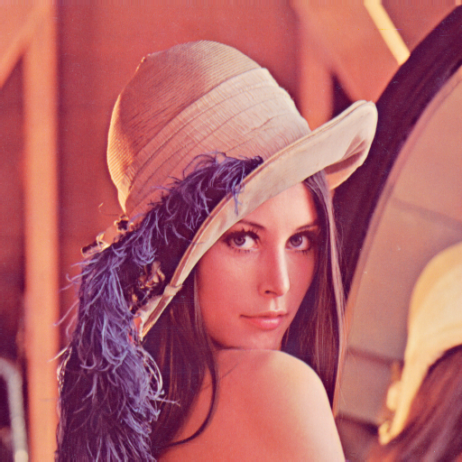

# 

# Prewitt

The Prewitt operator is used in image processing, particularly within edge detection algorithms. Technically, it is a discrete differentiation operator, computing an approximation of the gradient of the image intensity function. At each point in the image, the result of the Prewitt operator is either the corresponding gradient vector or the norm of this vector. The Prewitt operator is based on convolving the image with a small, separable, and integer valued filter in horizontal and vertical directions and is therefore relatively inexpensive in terms of computations like Sobel and Kayyali operators. On the other hand, the gradient approximation which it produces is relatively crude, for high frequency variations in the image. The Prewitt operator was developed by Judith M. S. Prewitt.

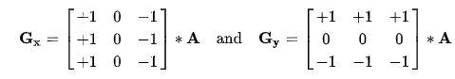



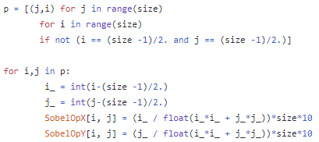

## Prewitt Results:

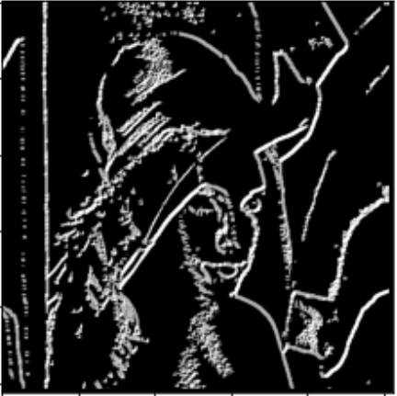(5x5)

# Sobel

The Sobel operator, sometimes called the Sobel–Feldman operator or Sobel filter, is used in image processing and computer vision, particularly within edge detection algorithms where it creates an image emphasizing edges. It is named after Irwin Sobel and Gary Feldman, colleagues at the Stanford Artificial Intelligence Laboratory (SAIL). Sobel and Feldman presented the idea of an "Isotropic 3x3 Image Gradient Operator" at a talk at SAIL in 1968. Technically, it is a discrete differentiation operator, computing an approximation of the gradient of the image intensity function. At each point in the image, the result of the Sobel–Feldman operator is either the corresponding gradient vector or the norm of this vector. The Sobel–Feldman operator is based on convolving the image with a small, separable, and integer-valued filter in the horizontal and vertical directions and is therefore relatively inexpensive in terms of computations. On the other hand, the gradient approximation that it produces is relatively crude, for high-frequency variations in the image.

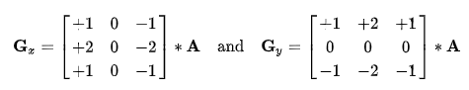



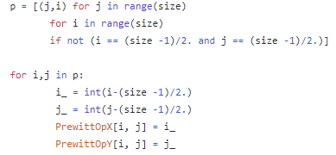

## Sobel Results:

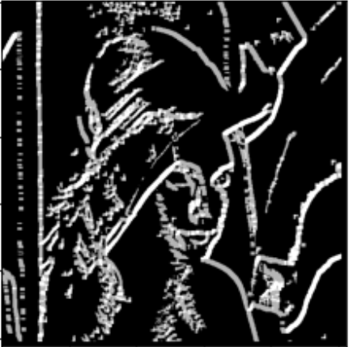(7x7)

# Compass

Unlike most edge detectors compute an average value for each side and then compute the Euclidean distance, the compass operator allows multiple values to exist on each side. We take the colours in the window and quantize them to a variable number of values (if we restricted the number of values to 1 on each side, it would be equivalent to other operators), each with a weight depending on how many pixels have that colour. Our representation is a signature, a set of point masses in colour space.

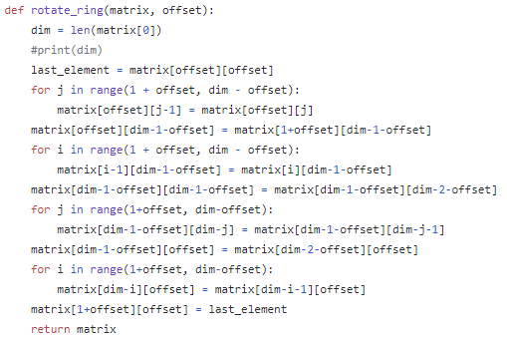

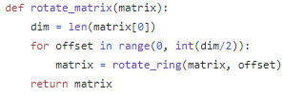

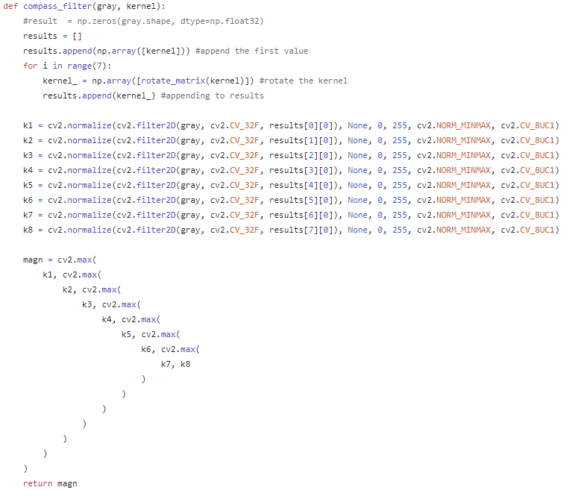

## Compass Results:

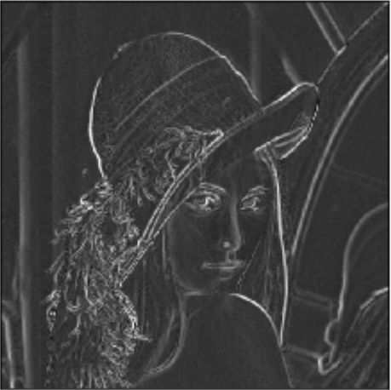(5x5)

# Nevatia Babu

The Nevatia-Babu edge masks are formed by computing the area to the sides of a dividing line segment oriented at the desired angle.

## Nevatia Babu Results:

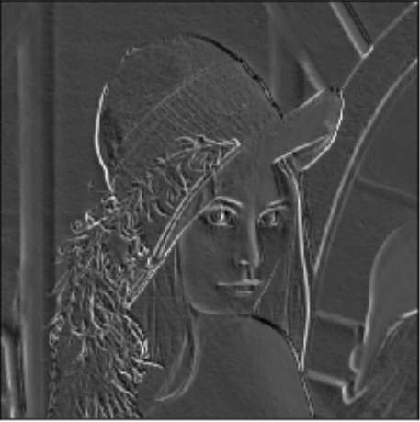(3x3)

# Bibliography

* <https://stackoverflow.com/questions/64843410/elements-from-list-are-overwritten-in-python/64845620#64845620>
* <https://stackoverflow.com/questions/37839572/how-to-rotate-a-matrix-by-one-element-anti-clockwise-n-times-using-c-or-in-pyt>
* <https://slideplayer.com/slide/8688306/>
* <https://www.iasj.net/iasj?func=fulltext&aId=52927>
* <https://stackoverflow.com/questions/9567882/sobel-filter-kernel-of-large-size/41065243#41065243>
* <https://www.researchgate.net/publication/334001329_Expansion_and_Implementation_of_a_3x3_Sobel_and_Prewitt_Edge_Detection_Filter_to_a_5x5_Dimension_Filter>
* <https://www.youtube.com/watch?v=C_zFhWdM4ic>
* <https://www.youtube.com/watch?v=uihBwtPIBxM&t=301s>
* <https://en.wikipedia.org/wiki/Sobel_operator>
* https://en.wikipedia.org/wiki/Prewitt_operator